Syeda Reeha Quasar

14114802719

4C7

Aim

To plot unit step function and square wave function.

Experiment - 8

APPLIED MATHEMATICS LAB

# **EXPERIMENT – 8**

## **Aim:**

To plot unit step function and square wave function.

**Source Code:**

clc;

printf('\n\n Name - Syeda Reeha Quasar \n Enrolment No. - 14114802719 \n Group - C7 \n\n')

x = [1 -1 2 3 4 -2]

y = [2 0 3 -2 5 -3]

plot2d(x, y)

# Output:

# 

*//generation of square wave*

clc;

printf('\n\n Name - Syeda Reeha Quasar \n Enrolment No. - 14114802719 \n Group - C7 \n\n')

x = [1 2 3 4 5 6 7 8 9 10];

y = [5 0 5 0 5 0 5 0 5 0];

plot2d2(x, y)

# **Output:**

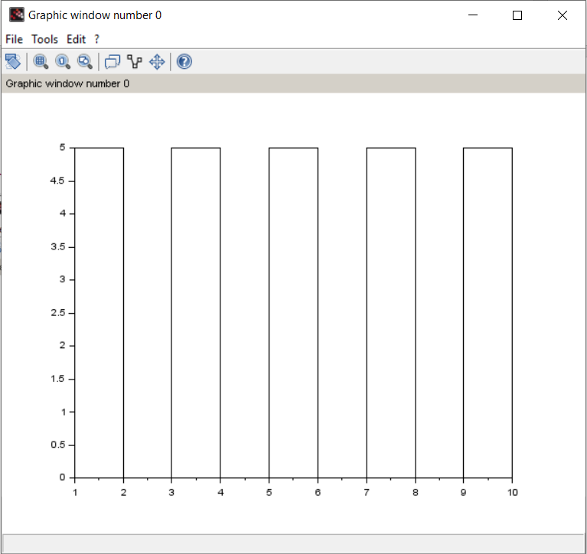

*// unit step function*

clc;

x = [-1 -2 -3 -4 -5 1 2 3 4 5];

y = [0 0 0 0 0 1 1 1 1 1];

*//plot(x, y, 'ro');*

plot(x, y, 'd*');

# **Output:**

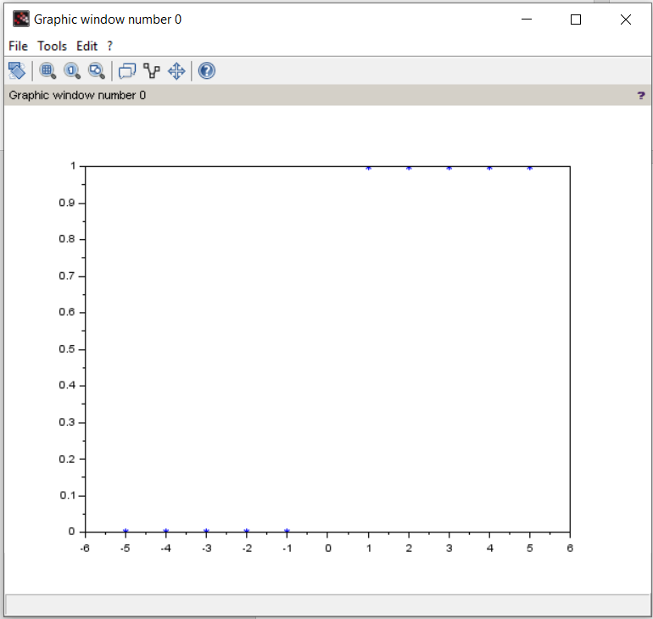

*// unit step function*

clc;

x = [-1 -2 -3 -4 -5 1 2 3 4 5];

y = [0 0 0 0 0 1 1 1 1 1];

plot(x, y, 'ro');

*//plot(x, y, 'd*');*

# **Output:**

